TASK-HANDS ON DOCKER
SHRUTI SAKHARKAR

- First start by making an instance
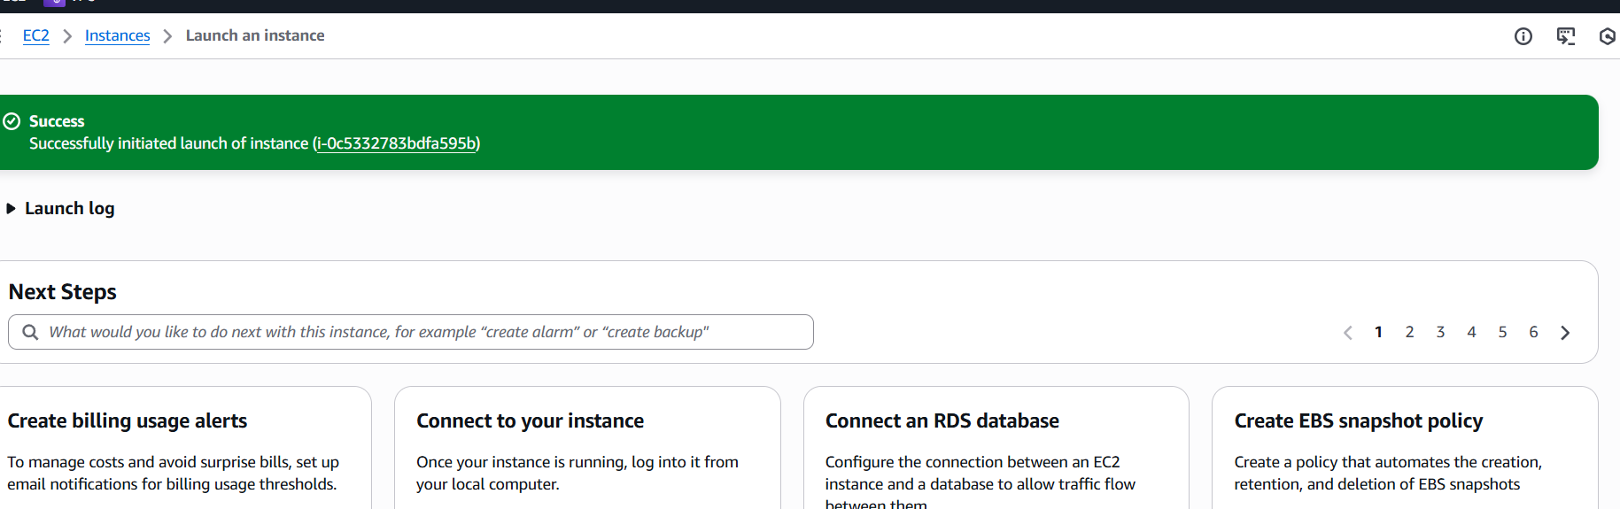
Then create a session on terminal and Use commands update and upgrade and install docker using command
Sudo apt install -y docker.io and check the version using command Docker –version
Give the host name by using command
sudo hostnamectl set-hostname dockerproject
CREATION OF DOCKERFILE:
A Dockerfile is a blueprint for creating Docker images. It defines the base image, software to install, files to copy, environment variables, ports to expose, and the command to run.
Commands used and what they do -
1.#pull the base image which gives all required tools and liberies
FROM nginx:alpine → Use a lightweight Nginx image
2.#create a folder where the app code will be stored
WORKDIR /app
3.#copy the source code from your HOST machine to your container
COPY seodocker/ ... → Copy your website files into the container

4.#compile the application code
RUN rm -rf ... → Remove default HTML files
5. #open the port
EXPOSE 80 → Open port 80
6.#run the application(container is already build till 4th step , now only commands are injected inside container)
CMD ["nginx", "-g", "daemon off;"] → Start Nginx when container starts

Here is the file I created –( touch Dockerfile) for my project and used vim command - vim Dockerfile and moved that file to directory.
create a directory name dockerf using command mkdir name so that both the dockerfile and project file is in same directory.
Also transferred my project files from local server using scp command –
scp -r -i docker.pem seodocker "seodocker" ubuntu@44.192.78.100:/home/ubuntu
-r is used to copy a folder and all its contents

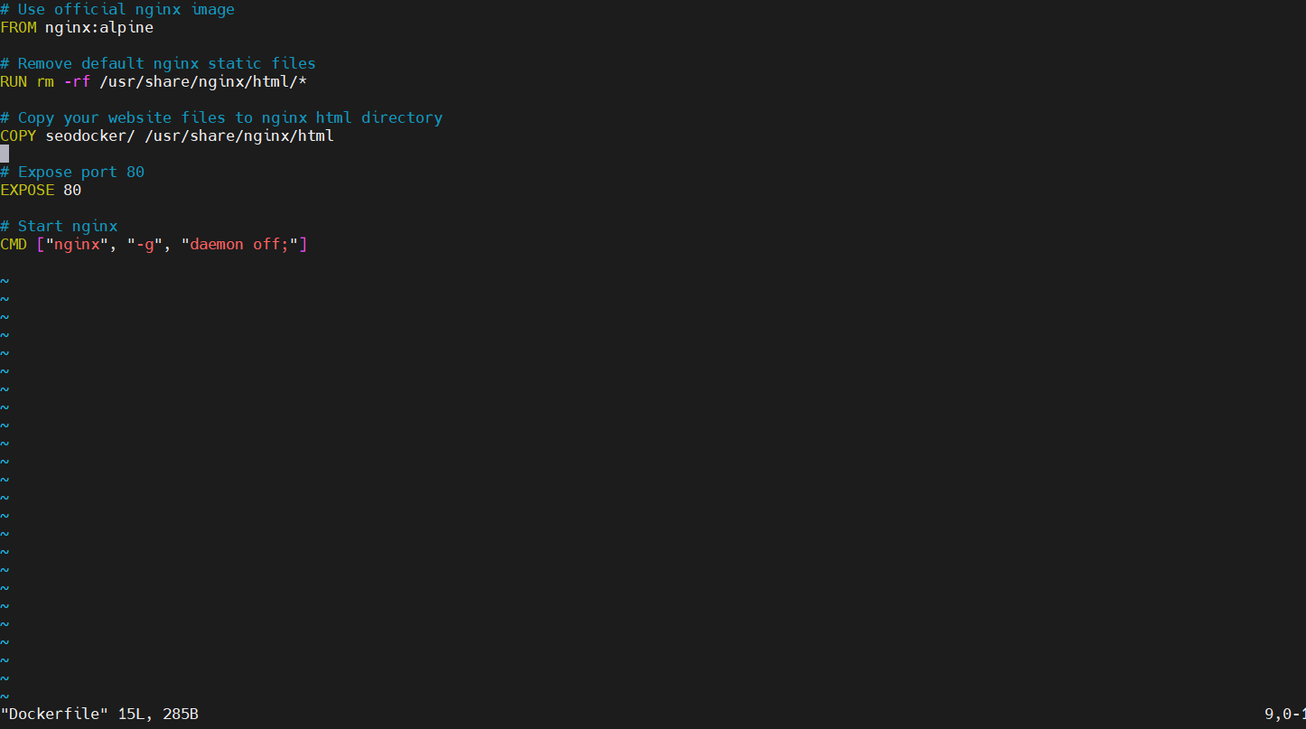
Check if both the files are in same directory because
- If your project files are outside this folder, COPY commands will fail.
• Keeping the Dockerfile and project in the same directory ensures Docker can access all files easily.
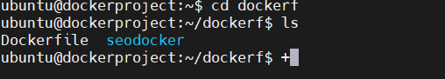
BUILDING THE IMAGE-
USE COMMAND - docker build -t myimage .
command I used for my project-
docker build -t seodocker .

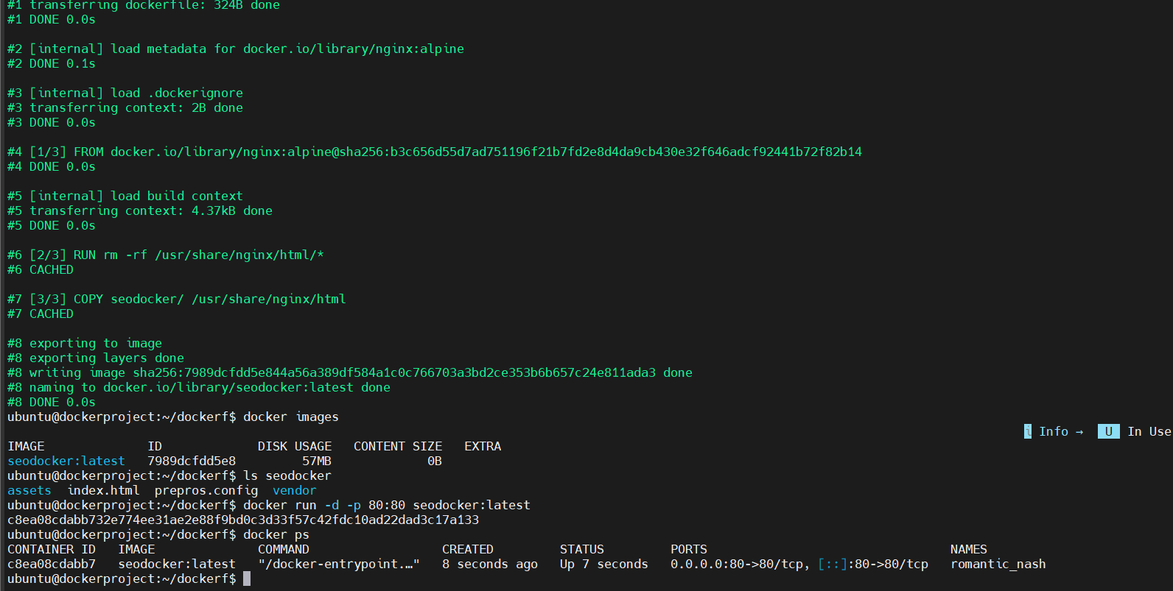
Successfully build .
Check by using command docker images it will show the build image.
RUNNING AN IMAGE-
Now run the image using command – docker run -d -p 80:80 imagename
I used - docker run -d -p 80:80 seodocker:latest .And use command docker ps to know details .
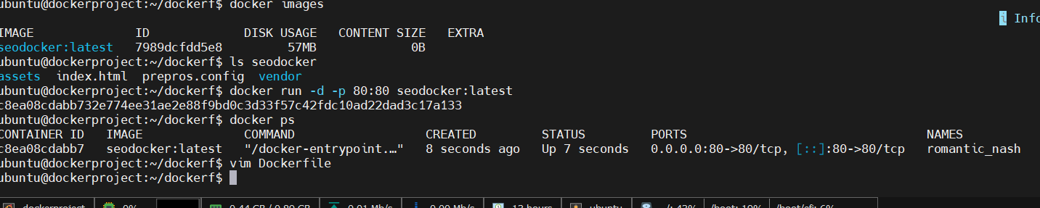
After running copy the ip address and run the project.

